**Classroom Activity​: Write a program for fetching data from fake json data from using Await/Async​**

**Html code**

**​**

<!DOCTYPE html>

<html lang="en">

<head>

<meta charset="UTF-8">

<meta name="viewport" content="width=device-width, initial-scale=1.0">

<title>Fetch Data with Async/Await</title>

</head>

<body>

<button id="fetchButton">Fetch Data</button>

<div id="dataContainer"></div>

<script src="script.js"></script>

</body>

</html>

**Script code**

// Function to fetch data from a fake JSON API using async/await

async function fetchData() {

try {

const response = await fetch('https://jsonplaceholder.typicode.com/posts');

if (!response.ok) {

throw new Error('Network response was not ok ' + response.statusText);

}

const data = await response.json();

displayData(data);

} catch (error) {

console.error('There has been a problem with your fetch operation:', error);

}

}

// Function to display fetched data

function displayData(data) {

const dataContainer = document.getElementById('dataContainer');

dataContainer.innerHTML = ''; // Clear any existing content

data.forEach(post => {

const postElement = document.createElement('div');

postElement.innerHTML = `<h3>${post.title}</h3><p>${post.body}</p>`;

dataContainer.appendChild(postElement);

}); }

// Add click event listener to the button

document.getElementById('fetchButton').addEventListener('click', fetchData);

**Output:**

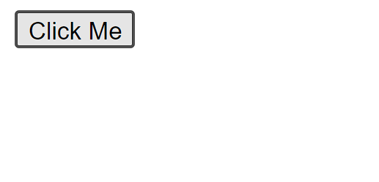

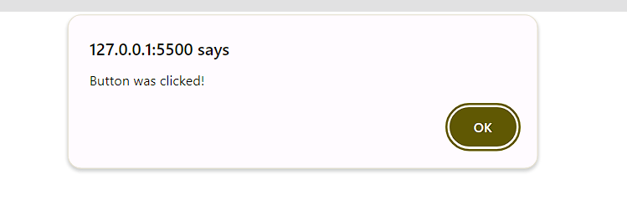

**Execution-Steps:**

* Create a JavaScript file with any name
* Write the code
* Run the code in the terminal using F5 or right click and go to inspect and you can get the output in the console as well.